附件：项目本年度外方合作导师简历

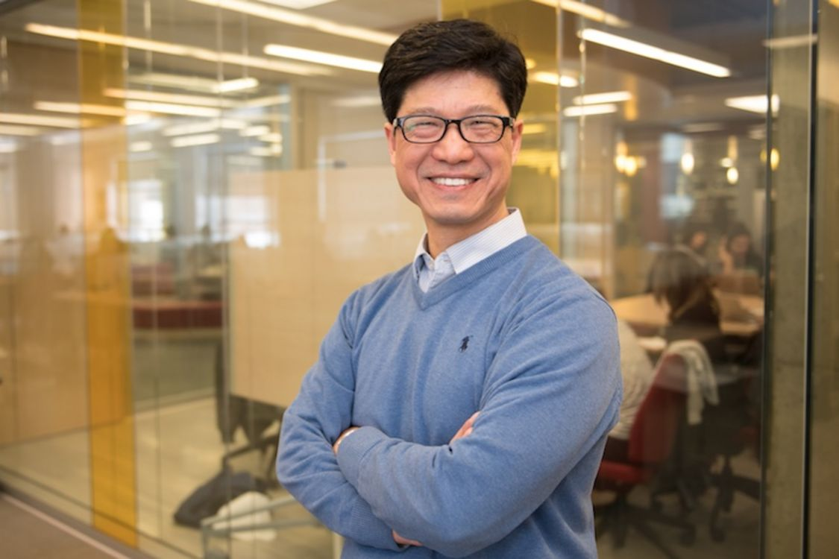
Jian-Yun Nie
Full professor, Director of RALI lab (Applied research on Computational Linguistics)
Department of computer science and operations research (DIRO)
Université de Montréal,
C.P. 6128, succursale Centre-ville
Montréal, Québec, H3C 3J7, Canada
email: nie@iro.umontreal.ca http://rali.iro.umontreal.ca/nie/jian-yun-nie-en/

- Professor at DIRO, Université de Montréal since 1991.
- Multiple visiting positions at Huawei Noak Ark, Baidu, Microsoftt Research, Renmin University, Tsinghua Uiv., Peking Univ., HIT, …

Research areas
- Information retrieval and recommendation
- Natural language processing, question answering, dialogue
- Knowledge graph and knowledge-based reasoning
- Artificial intelligence
Honors
- Award of Discovery Acceleration Supplements (DAS), NSERC, 2008 and 2013
- Best paper awards: AIRS 2019, AIRS 2018, SIGIR 1999
- Best paper runner up: SIGIR 2015, CLEF 2015

Selected Recent Publications (last 3 years) Google Scholar citations: 10000+, H-Index: 47 (https://scholar.google.com/citations?user=W7uYg0UAAAAJ&hl=en)

Peer-reviewed Journal articles (last 3 years)
- Reem El Sherif, Alexis Langlois, Pan Du, Jian-Yun Nie, James Thomas, Quan Nha Hong, and Pierre Pluye (2020) Identifying empirical studies for mixed studies reviews: The mixed filter and the automated text classifier. Education for Information, 36(1): 101-105.
- Y Zhu, Z Dou, JY Nie, JR Wen (2020) ReBoost: a retrieval-boosted sequence-to-sequence model for neural response generation, Information Retrieval Journal 23 (1), 27-48
- Ho Chung Wu, Robert W. P. Luk, Kam-Fai Wong, Jian-Yun Nie (2019) Binary Independence Language Model in a Relevance Feedback Environment. International Journal of Software Engineering and Knowledge Engineering 29(6): 873-895
- Deveaud, R., Mothe, J., Nie, J-Y., Ullah, M.Z. (2019) Learning to Adaptively Rank Document Retrieval System Configurations, ACM Transactions on Information Systems (TOIS), 37(1), Article 3, 41 pages. DOI: https://doi.org/10.1145/3231937
- Alexis Langlois; Jian-Yun Nie; James Thomas; Quan Nha Hong; Pierre Pluye (2018) Discriminating between empirical studies and nonempirical works using automated text classification, Research Synthesis Methods, 9(4): 587-601.
- Deveaud, R., Mothe, J., Nie, J-Y., Ullah, M.Z. (2018) Learning to Adaptively Rank Document Retrieval System Configurations, ACM Transactions on Information Systems (TOIS), (in press).
- T Bai, X Zhao, Y He, JY Nie, JR Wen (2018) Characterizing and Predicting Early Reviewers for Effective Product Marketing on E-Commerce Websites, IEEE Transactions on Knowledge and Data Engineering, 30(12): 2271-2284.
- Zhengbao Jiang; Zhicheng Dou; Wayne Xin Zhao; Jian-Yun Nie; Ming Yue; Ji-Rong Wen. Supervised Search Result Diversification via Subtopic Attention, IEEE Transactions on Knowledg and Data Engineering, 30(10): 1971-1984, 2018.
- Dubé L., Du, P., McRae, C., Jayaraman, S. & Nie, J.Y. (2018). Enabling Convergent Innovation Through an Artificial Intelligence Social Media Platform: The Case of Food. Technology Innovation Management Review, 8(2): 49-65.
- Dexi Liu, Jian-Yun Nie, Changxuan Wan, Xiping Liu, Shumei Liao, Guoqiong Liao, Minjuan Zhong, Tengjiao Jiang (2017) Extraction and feature analysis of sentiment words on microblogs based on classification, Chinese Journal of Computer (online 25/05/2017).
- K. Umemoto, R. Song, J.Y. Nie, X. Xie, K. Tanaka, Y. Rui (2017) Search by Screenshots for Universal Article Clipping in Mobile Apps, ACM TOIS, 35(4) 34:1-34:27.
- Zeyang Liu, Jiaxin Mao, Chao Wang, Qingyao Ai, Yiqun Liu, Jian-Yun Nie (2017) Enhancing click models with mouse movement information. Inf. Retr. Journal, 20(1): 53-80.

Peer-reviewed conference papers (last 3 years)
- Shanshan Wang, Pengjie Ren, Zhumin Chen, Zhaochun Ren, Jian-Yun Nie, Jun Ma, and Maarten de Rijke. (2020) Coding Electronic Health Records with Adversarial Reinforcement Path Generation. SIGIR.
- Yutao Zhu, Ruihua Song, Zhicheng Dou, Jian-Yun Nie and Jin Zhou (2020) ScriptWriter: Narrative-Guided Script Generation, ACL.
- Kai Zhao, Ting Bai, Bin Wu, Bai Wang, Youjie Zhang, Yuanyu Yang and Jian-Yun Nie (2020) Deep Adversarial Completion for Sparse Heterogeneous Information Network Learning, The Web Conference.
- Anwen Hu, Zhicheng Dou, Jian-Yun Nie, Ji-Rong Wen. (2020). Leveraging Multi-token Entities in Document-level Named Entity Recognition. AAAI.
- Lixin Zou, Ting Bai, Pan Du, Zhuo Zhang, Weidong Liu, Dawei Yin, Jian-Yun Nie. (2020). Pseudo Dyna-Q: A Reinforcement Learning Framework for Interactive Recommendation. WSDM.
- Yifan Nie, Jian-Yun Nie (2019) Cross-Level Matching Model for Information Retrieval, AIRS (Best paper award).
- Zhongxia Chen, Ruihua Song, Xing Xie, Jian-Yun Nie, Xiting Wang, Fuzheng Zhang, Enhong Chen (2019) Neural Response Generation with Relevant Emotions for Short Text Conversation. NLPCC (1): 117-129
- Yifan Nie, Jiyang Zhang, Jian-Yun Nie (2019) Integrated Learning of Features and Ranking Function in Information Retrieval. ICTIR: 67-74
- Yanru Qu, Ting Bai, Weinan Zhang, Jian-Yun Nie, Jian Tang (2019) An End-to-End Neighborhood-based Interaction Model for Knowledge-enhanced Recommendation. 1st Int. Workshop on Deep Learning Practice for High-Dimensional Space Data (with KDD). (Best Paper Award)
- Ting Bai, Lixin Zou, Xin Zhao, Pan Du, Weidong Liu, Jian-Yun Nie and Ji-Rong Wen (2019) CTRec: A Long-Short Demands Evolution Model for Continuous-Time Recommendation, SIGIR, pp. 675-684
- Shuqi Lu, Zhicheng Dou, Jun Xu, Jian-Yun Nie and Ji-Rong Wen (2019), PSGAN: A Minimax Game for Personalized Search with Limited and Noisy Click Data, SIGIR, pp. 555-564
- Zhiqing Sun, Jian Tang, Pan Du, Zhi-Hong Deng and Jian-Yun Nie (2019) DivGraphPointer: A Graph Pointer Network for Extracting Diverse Keyphrases, SIGIR, pp. 755-764
- Zhiqing Sun, Zhi-Hong Deng, Jian-Yun Nie, Jian Tang (2019) RotatE: Knowledge Graph Embedding by Relational Rotation in Complex Space, ICRL.
- Xiangsheng Li, Yiqun Liu, Xin Li, Cheng Luo, Jian-Yun Nie, Min Zhang and Shaoping Ma (2018) Hierarchical Attention Network for Context-Aware Query Suggestion, AIRS (Best paper award)
- Lei Mei, Pengjie Ren, Zhumin Chen, Liqiang Nie, Jun Ma and Jian-Yun Nie (2018) An Attentive Interaction Network for Context-aware Recommendations, CIKM, pp.159-166. (#7 6-week top downloaded paper on ACM DL)
- Songwei Ge, Zhicheng Dou, Zhengbao Jiang, Jian-Yun Nie, and Ji-Rong Wen, Personalizing Search Results Using Hierarchical RNN with Query-aware Attention, CIKM, 2018, pp.347-356.
- Yifan Nie, Yanling Li, Jian-Yun Nie (2018) Empirical Study of Multi-level Convolution Models for IR Based on Representations and Interactions, ICTIR, pp. 59-66.
- Yiping Song, Cheng-Te Li, Jian-Yun Nie, Ming Zhang, Dongyan Zhao, Rui Yan: An Ensemble of Retrieval-Based and Generation-Based Human-Computer Conversation Systems. IJCAI 2018: 4382-4388
- Pan Du, Jian-Yun Nie (2018) Mutux at SemEval-2018 Task 1: Exploring Impacts of Context Information On Emotion Detection. SemEval@NAACL-HLT 2018: 345-349
- Yifan Nie, Alessandro Sordoni, Jian-Yun Nie (2018) Multi-level Abstraction Convolutional Model with Weak Supervision for Information Retrieval. SIGIR 2018: 985-988
- Ting Bai, Jian-Yun Nie, Wayne Xin Zhao, Yutao Zhu, Pan Du, Ji-Rong Wen (2018) An Attribute-aware Neural Attentive Model for Next Basket Recommendation. SIGIR 2018: 1201-1204
- WF Cheng, CC Wu, R Song, J Fu, X Xie, JY Nie (2018) Image inspired poetry generation in XiaoIce, arXiv preprint arXiv:1808.03090
- Zhengbao Jiang, Ji-Rong Wen, Zhicheng Dou, Wayne Xin Zhao, Jian-Yun Nie, Ming Yue (2017) Learning to Diversify Search Results via Subtopic Attention, SIGIR, pp. 545-554.
- Zhanyi Liu, Zhengyu Niu, Jian-Yun Nie, Hua Wu, Haifeng Wang (2017) Conversation in IR: its role an utility, SIGIR Workshop on Conversational Approaches to IR.
- Ermakova L., Goeuriot L., Mothe J., Mulhem P., Nie JY., SanJuan E. (2017) CLEF 2017 Microblog Cultural Contextualization Lab Overview. pp 304-314. In: Jones G. et al. (eds) Experimental IR Meets Multilinguality, Multimodality, and Interaction. CLEF 2017. Lecture Notes in Computer Science, vol 10456. Springer.

Professional services
- Journal Editorial board
- Big Data Journal (Associate editor), 2018- ;
- Computational Intelligence (Associate editor) 2015 -;
- Foundation and Trends in Information Retrieval, 2011-2020;
- Information Retrieval Journal, 2007 -;
- Journal of Chinese Information Processing, 2006-
- Keynote/Invited speaker:
- Conversational recommendation, WSDM workshop on NLP2Rec, 2020
- Conversational information retrieval. Asian Summer school on IR, Haikou, 2019
- CCF-ADL lecture: 2016, 2018
- Keynote speech: 2018 International Conference on Data Science, 2018 International Workshop on Mining of Massive Data and IoT, SIGIR workshop on Axiomatic approaches to IR 2017, NLPCC 2015, CCIR 2014, …
Conference/workshop Program committee (PC) member (selected):
2020: ACM-SIGIR (senior member), ACL, WSDM (senior member), CIKM, AIRS, WWW (area chair), EMNLP, COLING (area chair), ICLR, NeurIPS …
2019: ACM-SIGIR (PC chair), ACL, WSDM, CIKM, AIRS, ICTIR, WWW, Big Data, …
2018: ACM-SIGIR (area chair), WSDM, AAAI, ECIR, CIKM, CLEF, AIRS, NLPCC, ICTIR, CORIA, TALN, Big Data …
2017: ACM-SIGIR (area chair), WSDM, ECIR, CIKM, FIRE, CLEF, AIRS (chair), Big Data (PC chair) …

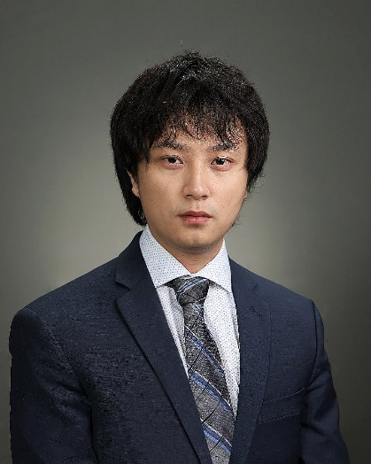
刘邦博士现任蒙特利尔大学计算机与运筹学系助理教授、RALI 实验室成员、MILA魁北克人工智能研究所成员。研究方向包括且不限于：natural language processing, text Mining, deep learning and reasoning, graph learning, mutitask and multimodal learning, AI + X（e.g., AI for Health, Art）等。研究成果发表在ACL, WWW, KDD, SIGMOD, TKDD, ICDM, CIKM, TON等诸多顶会和期刊上，并广泛应用于实际应用（如：QQ浏览器，手机QQ，微信等）。其研究曾获得Governor General’s Gold Medal nomination（2020）、George Walker PhD Award in Electrical Engineering（2020）、腾讯犀牛鸟卓越奖等多项荣誉。

个人主页：
http://www-labs.iro.umontreal.ca/~liubang/

希望申请者：
1. 对研究充满热情，self-motivated；
2. 有扎实的数理基础和英语写作交流能力；
3. 有顶会paper发表经验加分。

